 | Big Ideas
 |  | Description
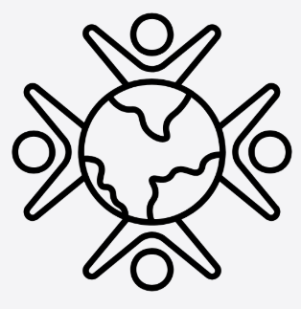 | Community and culture | Pupils will learn about and make comparisons between different civilisations and societies through history. They will learn about key aspects such as architecture, art, civilisations, societies, homes, religion, settlement, games and sports. Pupils will learn about a diverse range of significant figures and how they shaped the world we live in.
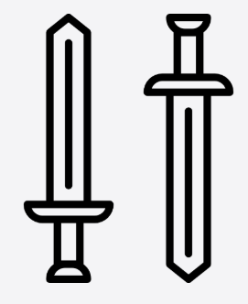 | War, conflict, Invasion and disasters | Throughout history, major changes have occurred as a result of significant events including war, invasion or disasters. Pupils will look at the reasons why these happened and the impact they had. They will learn about conquest, invasion, defence, occupation, the military and war as well as disasters such as fire and plague
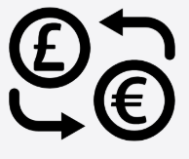 | Migration & Trade | Pupils will learn how people moved and how they traded goods with each other and the impact of this. They will study key trade routes and migration pathways.
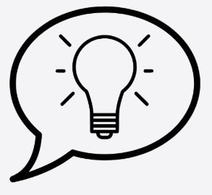 | Ideas and communication | Pupils will learn how people invented throughout history and the impact of this. They look at key inventions, transport, tools and technology and how these changed over time.
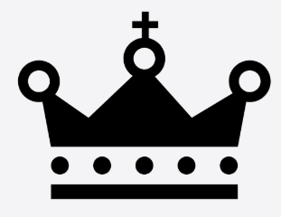 | Empire, power & government | Pupils will learn about and make comparisons between different civilisations, exploring life of the rich and the rulers compared to other members of society. They will look at countries, democracy, empires, government, law, monarchy and rulers, rich and poor and slavery from key historical periods they study. Pupils will also study how Religion played its part in empires.
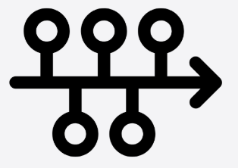 | Chronology | Pupils will learn to use simple time-related language, sequence events from within and beyond living memory, and order events on timelines. They will learn to use terms such as *before, after, past, present, then,* and *now*, and understand the meanings of BC, AD, BCE, and CE. Pupils will also learn to place dates and key events accurately on timelines, both within a single historical period and in relation to other periods, using increasingly precise dates to describe and sequence events.

SUBSTANTIVE KNOWLEDGE |  |  |  | DISCIPLINARY KNOWLEDGE
Declarative Knowledge / concepts |  |  |  | The knowledge & skills required to be a Historian.
Community & Culture |  | Helps pupils understand how groups of people live together, share beliefs, traditions and ways of life, and how these shape their everyday experiences and identities in the past. Pupils will learn about a diverse range of significant figures and how they shaped the world we live in. |  | 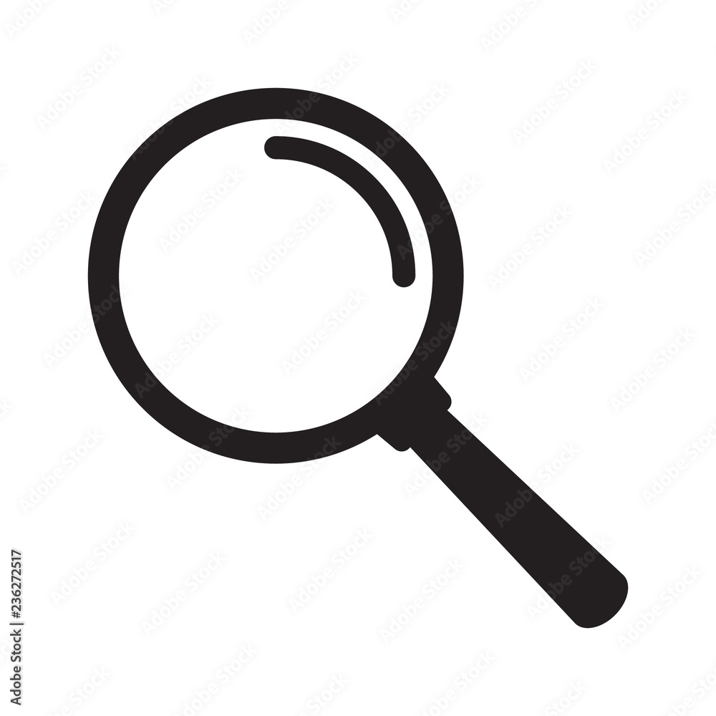 | Historical Enquiry | Build understanding of how knowledge about the past is constructed from sources
 |  |  |  | 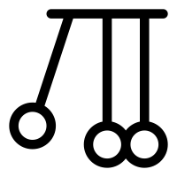 | Cause & Consequence | Analysing why events happened
Religion |  | Helps pupils understand the beliefs, practices and spiritual traditions that shaped people’s values, choices and ways of life in the past. |  |  | Cause & Consequence | Analysing why events happened
Empire & power |  | Helps pupils understand how groups gained, used and maintained control over people and places, and how this shaped relationships, societies and events in the past. |  | 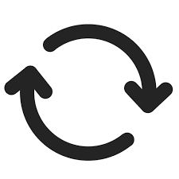 | Change and Continuity | Analysing the pace, type and extent of change across time periods including what impact it had
Warfare |  | Helps pupils understand why conflicts happened, how they were fought, and how war affected people, societies and change in the past. |  |  | Change and Continuity
Government & Monarchy |  | Helps pupils understand how societies were organised, the roles of rulers and governing bodies, and how decisions and authority influenced people’s lives in the past. |  | 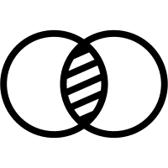 | Similarity and Difference | Within the same time period eg: between groups, places or societies
Migration |  | Helps pupils understand why people moved, where they went, and how these movements shaped communities, cultures, and societies in the past. |  |  | Similarity and Difference
Invasion |  | Helps pupils understand when and why groups entered other lands by force, and how these events affected communities, power structures, and everyday life in the past |  |  | Historical Significance | Why some events or people are deemed to be significant by historians
Trade |  | Helps pupils understand how people exchanged goods, services, and ideas, and how these interactions influenced communities, wealth, and relationships in the past. |  |  | Historical Significance
Inventions /  Discoveries |  | Helps pupils understand how new ideas, tools, and technologies were created or found, and how they changed people’s lives, societies, and the course of history. |  | 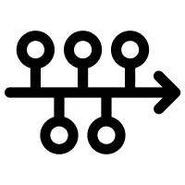 | Chronological awareness | How history fits into a time frame, the chronology within the time period as well as the sequence of time periods globally.

 | Autumn | Spring | Summer
Year 3 | Stone Age Britain: What do archeologists think they know about it?  Big Ideas: Community and culture, Ideas and communication, Chronology | Bronze Age and Iron Age: How did life change during this time?  Big Ideas: Community and culture, Ideas and communication, Chronology, Migration and trade | What was life in Croydon like in the Victorian Era?  Big Ideas: Community and culture, Empire, power and government, chronology, Ideas and communication
Year 4 | Ancient Egypt: What stayed the same across 3000 years?  Big Ideas: Community and culture, Ideas and communication, Chronology, Empire, power and government | Who are the Anglo Saxons and how did they shape Britain?  Big Ideas: Community and culture, War, conflict, invasion and disaster, Empire, power and government, Chronology | Vikings: Why did they come to Britain?  Big Ideas: Community and culture, War, conflict, invasion and disaster, Empire, power and government, Chronology
Year 5 | What was the impact of British rule in India?  Big Ideas: Community and culture, Empire, power and government, Chronology, Migration and trade | Ancient Greek civilisation: What do we know about Ancient Greece?  Big Ideas: Community and culture, War, conflict, invasion and disaster, Empire, power and government, Chronology | Ancient Greek civilisation: What is its most important legacy?  Big Ideas: Community and culture, Ideas and communication, Chronology
Year 6 | Benin: Why have people argued about the Benin Bronzes?  Big Ideas: Community and culture, War, conflict, invasion and disaster, Ideas and communication, Migration and trade, Empire, power and Government, Chronology | Ancient Rome: What impact did the Romans have on Britain?  Big Ideas: Community and culture, War, conflict, invasion and disaster, Ideas and communication, Migration and trade, Empire, power and Government, Chronology | How did World War II impact Britain?  Big Ideas: Community and culture, War, conflict, invasion and disaster, Ideas and communication, Empire, power and Government, Chronology

Disciplinary Knowledge
Historical Enquiry  Build understanding of how knowledge about the past is constructed from sources | Year 3 |  |  |  |  | Year 4 | Year 5 |  | Year 6
 | Can I name different sources of evidence?  Can I suggest suitable sources of evidence for historical enquiry?  Can I differentiate between fact and opinion?  Can I use research skills, with guidance, to find answers to specific questions? |  |  |  |  | Can I explain the difference between primary and secondary sources?  Can I use more than one source of evidence to gain an understanding of history?  Can I begin to analyse sources and evaluate them?  Can I present the information I have learnt in a variety of ways? | Can I discuss the usefulness of primary and secondary sources?  Can I use a range of information, including my own research, to present a historical argument?  Can I understand that some sources include facts and opinions and different evidence can lead to different conclusions.  Can I explain how historical artefacts can be used to help build up a picture of the past? |  | Can I analyse sources critically to evaluate the usefulness of them?  Can I recognise bias within sources and use this to evaluate the validity of them?  Can I select appropriate historical sources to gain a more accurate understanding?
Cause & Consequence  Analysing why events happened | Can I identify the impact of the past on our lives today? |  |  |  |  | Can I explain and give reasons for historical events and explain the impact?  Can I explain how an historical event impacted at least one of the big ideas studied? | Can I understand the impact of historical events on later periods of history?  Can I evaluate how historical events have impacted one or more of the big ideas studied? |  | Can I understand the impact of historical events on later periods of history?  Can I evaluate how a historical event has impacted one or more of the big ideas studied?
Change and Continuity  Analysing the pace, type and extent of change across time periods including what impact it had | Can I spot links between significant events?  Can I identify what changed and what stayed the same? |  |  |  |  | Can I explain links between significant events?  Can I explain what changed and what stayed the same? | Can I summarise the main events from a period of history, explaining the order of events and making connections between them?  Can I explain how or why things changed or did not change over time? |  | Can I summarise the main events from a period of history, explaining the order of events and making connections between them?  Can I justify how or why things changed or did not change over time?
Similarity and Difference  Within the same time period eg: between groups, places or societies | Can I identify similarities and differences within a time period in relation to society, culture, religion or ethnic diversity?  Can I recognise similarities and differences between a period of history and now? |  |  |  |  | Can I describe similarities and differences within a time period in relation to society, culture, religion or ethnic diversity?  Can I describe similarities and differences between a period of history and now? | Can I discuss the differences in the lives of people from different social classes, cultures, religions or races both between and within time periods?  Can I research more independently the similarities and differences between two or more periods of history? |  | Can I explain the differences in the lives of people from different social classes, cultures, religions and races both between and within time periods?  Can I undertake research in order to find similarities and differences between two or more periods of history and draw my own conclusions?
Historical  Significance  Why some events or people are deemed to be significant by historians | Can I identify historically significant people, key events within the past and the impact these have had? |  |  |  |  | Can I discuss historically significant people, key events and the impact these have had? | Am I aware of some pivotal events and people in modern British history?  Can I explain the impact of key historical people and events? |  | Can I explain key historical figures and pivotal events?  Can I evaluate the impact of key historical people and events?
Chronological awareness  How history fits into a time frame, the chronology within the time period as well as the sequence of time periods globally. | Can I discuss what is meant by the term chronology?  Can I place dates and events on a timeline correctly? |  |  |  |  | Can I explain what is meant by the term chronology?  Can I plot key events and dates on a timeline?  Can I begin to use the correct terms to describe events? (Year, decade, century, BC(BCE) and AD (CE). | Can I use the language of chronology in my historical discussions?  Can I place key events from a period of history on a timeline in relation to one other period of history?  Can I use the correct terms to describe events? (Year, decade, century, BC(BCE) and AD (CE). |  | Can I use the Language of chronology in my historical discussions?  Can I construct timelines with appropriate scales to show progression of time from one period of history to another?  Can I use more accurate dates when describing and sequencing events?  Can I use the correct terms to describe changes in history? (political, social, religious, technological, cultural)

Substantive Knowledge
Community, culture and diversity | Year 3 | Year 4 | Year 5 | Year 6
Community, culture and diversity | Can I recognise that society was organised in different ways in different cultures and time periods?  Can I recognise that communities from the past consisted of different groups with different roles and lifestyles?  Can I describe the changes that happened in Britain during prehistory (Stone Age, Bronze Age and Iron Age)?  Can I describe Victorian life in the context of our local area, Croydon?  Can I explain how the Victorians have shaped our lives today? | Can I recognise that society was organised in different ways in different cultures and time periods?  Can I understand how invaders and settlers influenced the culture of the existing population? | Can I understand that society was organised in different ways in different cultures and time periods?  Can I compare different civilisations that I have studied? | Can I explain how society was organised in different ways in different cultures and time periods?  Can I understand that there are differences between early and later civilisations?
Invasion |  | Can I recognise that there were different reasons for invading Britain? | Can I recognise the role of the British Empire in colonisation and how this affected other countries? | Can I explain the different reasons for invading Britain?  Can I recognise the key aspects of different historical battles?  Can I understand the origins of WW2?
Warfare |  | Can I explain how settlement created tensions and problems?  Can I begin to compare how warfare was different in different time periods? | Can I describe the conflict between the Athenians and the Spartans? | Can I describe warfare tactics specific to the Ancient Romans?  Can I understand the role of individuals during warfare?  Can I understand the impact of technology on warfare?
Trade | Can I identify how trading developed in the Iron Age? |  | Can I explain how trade developed between India and Britain? | Can I explain how trade developed during the Benin Kingdom?  Can I discuss how trade routes developed?  Can I understand how trade influenced communities?
Migration | Can I recognise how tribes/human groups migrated during the Stone, Bronze and Iron Age? | Can I recognise how and why societies/civilisations migrated to Britain? |  | Can I explore migration within the Roman Empire?
Religion |  | Can I compare beliefs in different cultures and times?  Can I recognise the significance of belief to  the Ancient Egyptians? | Can I explain the different beliefs that different cultures, times and groups hold?  Can I discuss how the beliefs of the Ancient Greeks impacted their lives?
Empire and power |  | Can I learn about Viking Kingdoms?  Can I learn about the power and influence of the Ancient Egyptians? | Can I explain how the British Empire affected India?  Can I learn about the power and influence of the Ancient Greeks? | Can I learn about the Ancient Kingdom of Benin?  Can I identify the impact of Britain on the Ancient Kingdom of Benin?  Can I explain the influence and spread of the Roman Empire?  Can I explain the origins of WW2?
Government and monarchy | Can I learn about Queen Victoria and her impact on the British Empire? | Can I recognise how civilizations were organised and structured in Ancient Egypt?  Can I recognise how civilizations were organised and structured during the Anglo Saxon period?  Can I recognise how civilizations were organised and structured during the Viking period? | Can I recognise how civilizations were organised and structured in Ancient Greece?  Can I recognise why Governments and Empires go to war? | Can I explain how civilizations were organised and structured in the Ancient Kingdom of Benin?  Can I explain how civilizations were organised and structured in Ancient Rome?  Can I explain how civilizations were organised and structured in South Africa during Apartheid?  Can I recognise why Governments and Empires go to war and the impact this has?
Inventions and discoveries | Can I identify how metal was created and how this influenced human activity?  Can I begin to recognise the impact of the industrial revolution? | Can I recognise how the Vikings managed to invade across the sea in longboats?  Can I identify how the Ancient Egyptians communicated through hieroglyphs? | Can I discuss how the Greeks developed sport through the Olympics?  Can I discuss the impact of Greek inventions and discoveries, including language on our life today? | Can I recognise how weapons have developed over time?  Can I identify how bronze plaques were made and their importance for the Ancient Kingdom of Benin?

