School Admissions Team
4th Floor
Bernard Weatherill House
8 Mint Walk
Croydon
CR0 1EA
Tel: 020 8726 6400
Email: school.admissions@croydon.gov.uk
Date: 9 September 2025

Dear Parent

Application for a place at a Secondary School in September 2026

Is your child currently in Year 6? If so you MUST apply for a secondary school place for them.

Apply now:
- Visit www.croydon.gov.uk/admissions to find out about the schools available and be guided through the steps in the application process and the online application form.
- If you are familiar with the process and already have an eAdmissions account you can apply straightaway at www.eadmissions.org.uk
Application deadline: 31 October 2025
If your application is late it will not be considered until all applications received on time have been processed and your child would be unlikely to receive a place at one of your preferred schools. Help your child by being one of the nine out of ten parents who apply on time.
You will be able to view the outcome of your application online on 2 March 2026.
If you require help making your application, please email school.admissions@croydon.gov.uk and someone will contact you to talk you through the application process.

Answers to many common questions are available at:
https://www.croydon.gov.uk/schools-and-education/schools/school-admissions/admissions-secondary-schools-university-technical-colleges-and-studio-schools/starting-secondary-school
If you have any additional queries please contact School Admissions at school.admissions@croydon.gov.uk or by telephone on 020 8726 6000 ext. 44041.
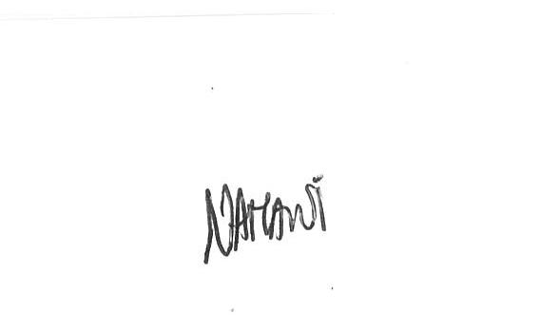
Yours sincerely

Niora Amani
Admissions Manager – Coordinated Admissions (primary and secondary)

